Introduction
SOLID is a set of five object-oriented design principles introduced by Robert C. Martin to make software easier to understand, maintain, test, and extend. These principles encourage loosely coupled, modular, and reusable code.
- Single Responsibility Principle (SRP)
A class should have only one reason to change. Each class should perform one well-defined responsibility. Example: A Report class should create report data, while a ReportPrinter class prints it.



- Open/Closed Principle (OCP)
Software entities should be open for extension but closed for modification. New features should be added by extending existing code rather than changing tested code.



- Liskov Substitution Principle (LSP)
Objects of a derived class should be replaceable with objects of the base class without affecting correctness. Derived classes must honor the behavior expected from the base class.


- Interface Segregation Principle (ISP)
Clients should not be forced to depend on methods they do not use. Prefer several small, focused interfaces over one large interface
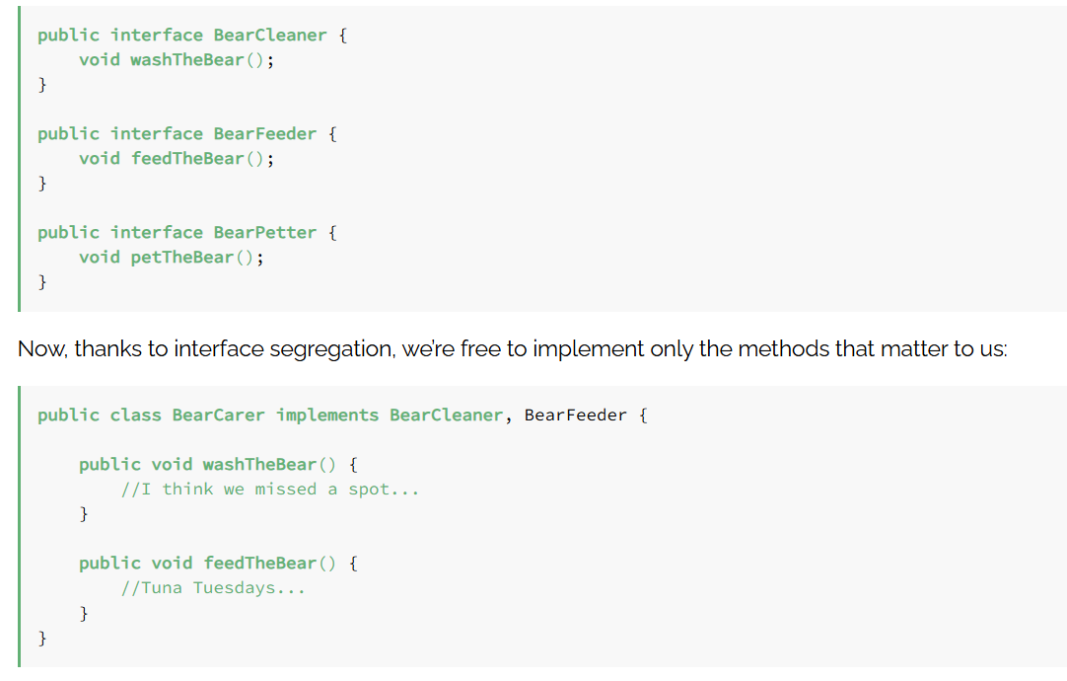

. 5. Dependency Inversion Principle (DIP)
High-level modules should depend on abstractions instead of concrete implementations. This reduces coupling and improves flexibility, testing, and maintainability.

